Javier Jesús Macossay-Hernández EE 348L

19 février 2016

**Prelab #4**

Exercise 2

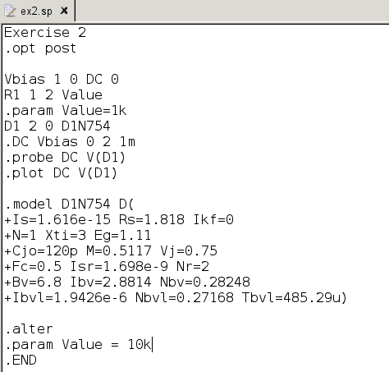

Exercise 2 Netlist

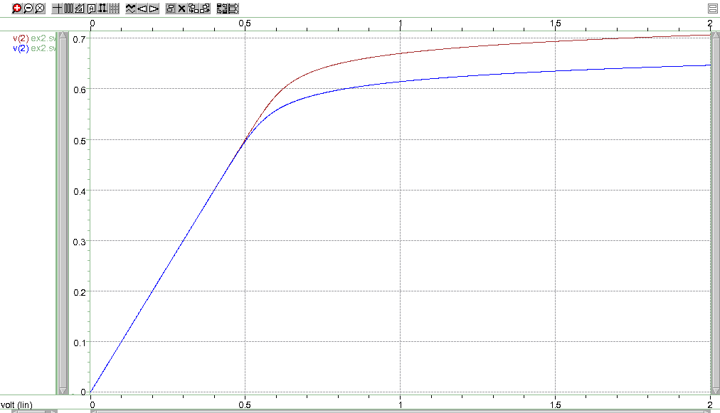

Diode Voltage for 1kΩ and 10kΩ Resistors

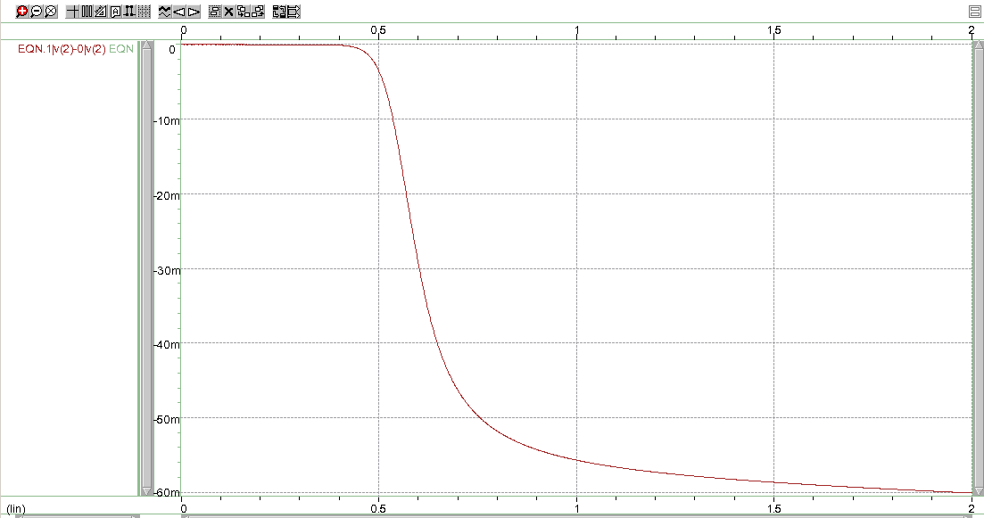

Difference in Diode Voltage for both Resistor Values

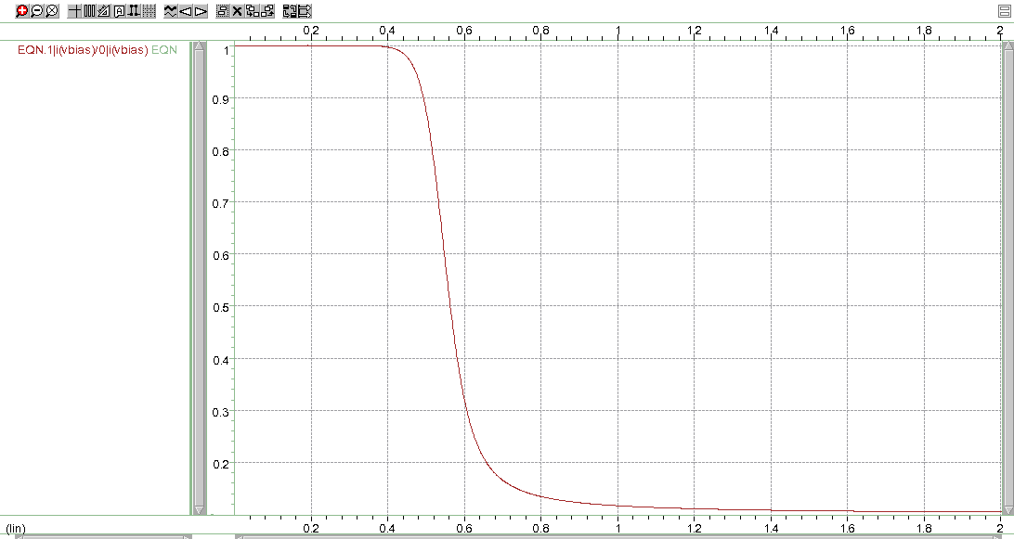

Ratio of Diode Current for both Resistor Values

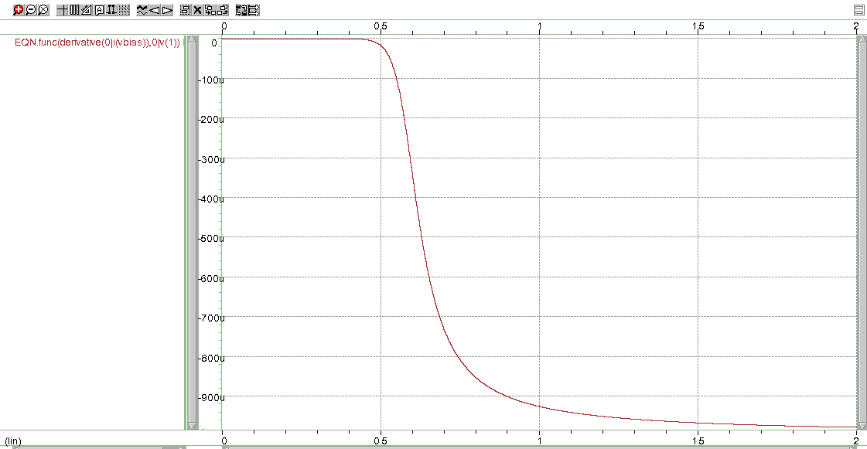

Derivative of the Current through the Diode versus Input Voltage for 1kΩ

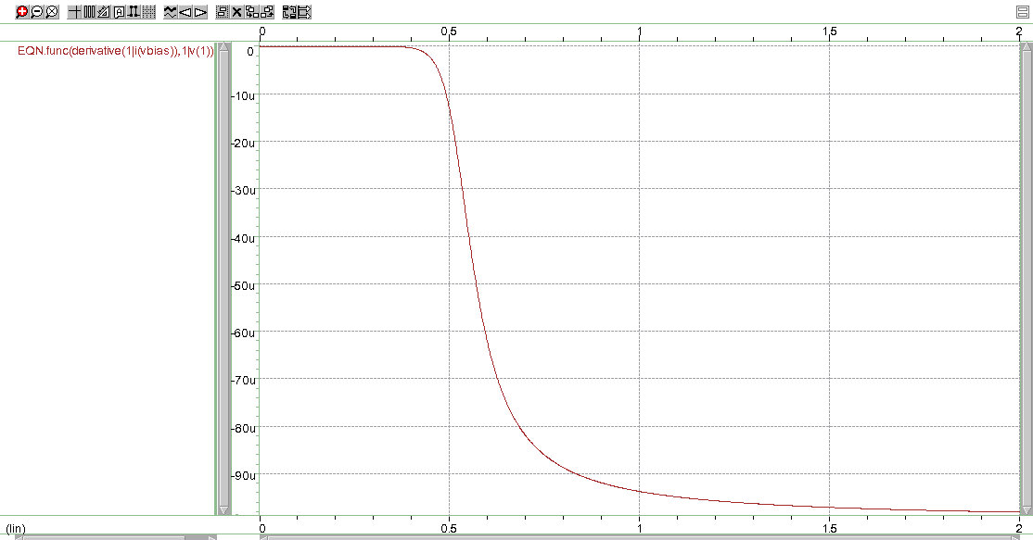

Derivative of the Current through the Diode versus Input Voltage for 10kΩ

1. When R is 1kΩ, the slope of the diode current saturate near the value of -1/R1, which is 979*10^-6
2. When R is 10kΩ, the slope of the diode current saturate near the value of -1/R2, which is 98.6*10^-6
3. The difference in the diode voltage saturate at -60 mV and the ratio of diode current saturate at 0.1. The results from the HSPICE simulations corroborate the results from the hand calculations. The plots show that with a small increase in voltage, the amount of current will be remarkably changed.

Exercise 3

From figure 4-13, it can be observed that the saturation current Isaturation = -32.24 mA. In addition, the non-ideality factor n = 27.57/25.9 = 1.06.

Exercise 4

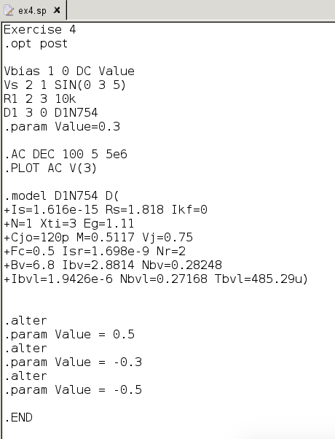

Exercise 4 Netlist